Writing a Scientific Manuscript:
Laboratory Methods in Molecular Biology
Sylvie Bardin © Winter 2009

The preparation of a laboratory report that describes, documents, and communicates the ideas and information obtained from experimental work, is an integral part of the scientific process. It is through written (and oral) dissemination of results that scientific knowledge advances. A laboratory report should follow the format of scientific manuscripts.

A scientific manuscript is usually divided into the following sections; Title/author’s name/keywords, Abstract, Introduction, Materials and Methods, Results, Discussion and References/ Literature Cited. A scientific manuscript must be written using the past tense and impersonal tone (avoid “you will”, “I do this”).

I- Title page

The title should be short and descriptive. It should give the reader a clear idea of the content of the paper. A general title such as "Biology 1010-Lab Report 1" is pointless; it tells the reader nothing about the content of the paper.

Example (from Bardin at al., 1996):
A phosphate transport system is required for symbiotic nitrogen fixation by Rhizobium meliloti.

The title must include:

- Factor(s) manipulated in the experiment – phosphate transport.
- The focus of the experiment – symbiotic nitrogen fixation.
- Specific name of subject/organism involved in the experiment – Rhizobium meliloti

If possible, give the key result of the study in the title (see example above).

Author’s name should follow the title. You should also provide five key words that define and/or describe the work performed. These key words are useful when looking for articles in literature databases. See below for examples of key words.

II- Abstract

The purpose of the abstract is to summarize the experiment performed and the results obtained. It consists of a single paragraph containing no more than 250 words and must include:

- One or two lines introducing the topic and stating the purpose (from Introduction).
- Briefly express the basic design of the study and describe the key techniques used (from Materials and Methods).
- The key findings presented in the paper (from Results), along with a brief statement of the significance of the results (from Discussion).
- Final conclusions/future prospects (from Discussion).

Example (from Bardin et al., 2004)
Seed treatment with non-sterilised powdered straws from 39 crops was tested for the control of Pythium damping-off of sugar beet. Four straws, flax, coriander, pea and lentil were effective in controlling the disease in soil artificially infested with Pythium sp. “group G”. Sterilising flax and pea straws eliminated the control effect of these straws. Wheat straw powder coated on sugar beet seeds increased the incidence of Pythium damping-off but this effect was reversed by the co-inoculation of wheat straws with the biocontrol agent Pseudomonas fluorescens 708. Coating sugar beet seeds with P. fluorescens 708 and flax or pea straws also increased the efficiency of the bacterial strain for the control of Pythium damping-off. Pea straws and to a lesser extent lentil straws produced volatile substances that affected mycelial growth of Pythium sp. “group G” on potato dextrose agar in Petri plates when the straws were mixed with water and left to ferment for two days. Fermentation of pea straws led to the accumulation of volatile ammonia, which was produced by the reduction of the large amount of nitrate stored in the straw. Reduction of nitrate and therefore the release of volatile ammonia did not occur in sterilised pea straws. However, fermenting sterile pea straws with bacteria from different genus restored nitrate reduction and the release of volatile ammonia, suggesting that micro-organisms associated with pea straws are responsible for the conversion of nitrate into volatile ammonia which in turn control Pythium damping-off disease in sugar beet.

Key words: Biocontrol; Seed treatment; Crop straws; Pythium sp. “group G”; Damping-off; Sugar beet

The Abstract SHOULD NOT contain:
- lengthy background information
- references to other literature
- abbreviations or terms that may be confusing to readers
- illustrations, Figures, Tables, or references to them.

Final note: The abstract is usually written after the manuscript has been completed since it is a summary of what is presented in the manuscript. To help you write the abstract, you can start by copying key sentences from the different sections of the manuscript. Then organize the sentences in sequence, delete unnecessary details, and connect the sentences to obtain a clear and concise paragraph that accurately summarizes the work presented in the manuscript. As you become more proficient you will most likely compose the Abstract from scratch.

III- Introduction

The bulk of the introduction summarizes the current knowledge on the topics investigated. This section is followed by a statement of purpose and a brief explanation of the rational and possible outcomes of the study investigated.

- Summary of the current knowledge
The introduction begins by providing some background information about the topics presented in the manuscript. Gathering background information means writing a mini literature review from peered-review journal articles in order to present what was know before your investigation started. You should organize your introduction so that you present the general information first (be careful, avoid being too general; make sure you keep your focus on the topics presented) and then narrow to more specific information. This section should be written so that it leads the reader to the purpose/rational of the experiment.

For example, the introduction for the abstract above would start with a description of the pathogen (Pythium sp. Group G, a fungi), followed by a description of the damping-off disease in general and in sugar beet in particular. Then you would describe the different ways (reported in the literature) the disease can be controlled and describe more specifically control using biocontrol (the control of the disease by micro-organisms). The use of plant residues for control of plant pathogens in general and Pythium in particular would then be reviewed as well as
the effect of ammonia released by plants on plant pathogen fungi.

- When reporting published work, make sure you cite the author(s) and date of the publication as described below:

To cite references in the introduction section, simply report the last name of author followed by the date of publication in brackets (John, 2003). If there are two authors, report the name of the two authors followed by the date of publication (Smith and Kenedy, 1999). If there are more than two authors, report the name of the first author followed by “et al.” (in italic) and the date of publication (Conaly et al., 2004).

- The literature cited in the introduction must be included in the Reference section (see below).
- Do not cite general background references such as encyclopedias, textbooks, lab manuals, etc., only primary research articles and review articles published in peered-reviewed journals are acceptable.

- Purpose and rational
The purpose/rational for the experiment are presented in the last paragraph of the introduction. The fact that this section is usually smaller that the first section does not mean that it is less important (some people will argue that this is the most important part of the introduction!). The purpose/question must clearly state what is going to be investigated. Please note that the word “hypothesis” is not desirable in a manuscript. Instead, you should write something like:

“The purpose of this study was to…” or “This study investigated…”

The rational for the experiment must also be presented in this section; this includes but is not limited to how the study is going to be performed (and how this does differ to previous work) and what the possible implications of the study will be (why is this important?).

- Ensure all literature cited in the introduction are properly referenced in the reference section.

IV- Materials & Methods

The M&M section describes, in a narrative way, the experimental procedures used to collect the data presented in the manuscript. Each experimental procedure or section should be presented as a unit. To do that, each section is organized under a subheading title. Some examples of titles include “Bacterial strains and media”, “Isolation of mutants using UV mutagenesis”, or “Statistical analysis”. The first sentence of each section must explain what this particular procedure is for (for example; Genomic DNA was extracted from peas by…).

The description should be detailed enough so that the experiment can be repeated by another
scientist. It should therefore contain all pertinent technical details, the instruments used and
experimental variable (e.g., temperature, incubation time, masses and volumes, concentrations,
voltage, type and % of gel, markers, sizes, centrifuge time and speed, etc.).

However, do not mention details of standard and generally known procedures (i.e., size of the flask used; how to use a microscope or a centrifuge; how to perform dilutions, etc.).

If a method has been published, you do not need to describe it again; instead, reference the article or book that describes the technique but make sure you include any modifications you may have made to that technique.

The difficulty in writing the M&M section comes as you have to decide the level of detail to include. You must determine which details are essential for another investigator to repeat the experiment.

For example, if in your experiment you incubate potato pieces in different concentrations of sucrose solutions, it is not necessary to explain that “the pieces were incubated in plastic cups labeled with a wax marking pencil” or to provide the size of the cups. In this case the concentration and volume of the sucrose solutions, the size of the potato pieces and how they were obtained (the variety of potato), and the amount of time the potatoes were incubated are important items to include.

When writing a M&M section, make sure you include:

- Scientific name and source of the organisms used
- Types of treatment.
- Number of replicates.
- Controls used.
- Variables measured
- Equipment used, model number and the manufacturer’s name (usually written in brackets)
- Chemicals and chemical companies (usually written in brackets). Describe the composition of the solutions used. If the solutions are standard and have been described in another publication, the publication can be cited.
- Specific procedures you developed
- The date and location of the sites for field studies.
- Explain how the data were collected and analyzed (statistical analysis, calculation such as the equation for the calculation of an enzyme activity, etc.)
- Computer software used

Other Tips for writing a M&M section
- M&M is not a laboratory manual or a recipe book. Never use point forms or bullets to write this section.
- Be careful not to be too wordy; try to combine several related actions into one sentence.
- Avoid using ambiguous terms to characterize treatments such as Tube 1, Tube 2, etc. (what do you have in Tube 1, Tube 2?).
- Avoid using “then”, “afterwards”, “next”, etc.
- Do not start sentences with a verb.
- Avoid starting your sentence with a number.

V- Results

The Results section presents the key results obtained using both, written paragraphs and Figures and/or Tables. The order in which the results are presented should be logical; it should describe the step-by-step results that allowed the investigators to answer the question posed in the Introduction. Many authors organize and prepare the result section before the rest of the report.

- Written paragraphs
The written paragraphs are usually divided into subsections with short subtitles. These paragraphs describe the results that are presented in the figures and tables with emphasis on the important findings. Do not describe in words what is already presented in the Tables or Figures. Instead, report the significant findings and trends, compare your data points with one another and with the controls, and explain what the data are showing. Refer to each Figure/Table presented in the manuscript by indicating the Figure/Table number (usually indicated in brackets) when describing the corresponding set of data (see examples below):

Note: Data points reported in a manuscript are always means of multiple replicates. Variation among the replicates of a treatment must be included by calculating the standard error. The number will therefore be written as “13.0 ± 1.5 cm” and in the case of a graph, the standard error will be represented by an error bar (see below). When you are comparing treatments to one another, you need to perform statistical tests (i.e., t-test, ANOVA, etc.) in order to determine if the treatments are significantly different or not. Without these tests the treatments cannot be compared.

Example:
“Despite the lack of clear antagonism against Pythium in the in vitro assays (this result was shown earlier in the paper), seed treatment with Rhizobium strains significantly (note: you can only use the word “significant” when your results have been statistically analyzed) increase emergence of sugar beet in soil infested with Pythium compared to the untreated control (Table 2).”

“Volatile substances released by moistened pea straw powders caused significant (P < 0.05) reduction in the growth of Pythium sp., whereas Pythium growth was not significantly (P > 0.05) reduced in the presence of coriander volatile substances compared to the untreated control (Table 3).”

“The amount of organic matter coated onto sugar beet seeds reached 2.9 ± 0.6 mg/seed for gelatine 1% and 2.6 ± 0.4 mg/seed for dextran 10% (Table 1). These two treatments provided the most uniform coating (Figure 1).”

- Do not try to interpret your results or give suggestions on the significance of the data obtained (the word “suggests” should not appear in the Result section); this is reserved for the discussion section.
- Do not compare your data with data that has been previously published.

- Tables and Figures
First, decide whether your data should be presented in a Table or Figure format (do not do both Table and Figure for the same data). Tables/Figures in your manuscript must be numbered in their order of appearance in the written portion of the Results section. If you have both tables and figures start the labeling with Table 1 and Figure 1. All Tables/Figures included in the manuscript must be referred to in the written part of the result section. Figures include graphs, diagrams, photos, drawings, maps, etc. Do not insert tables or figures into the body of your text. Table and figures must be placed at the end of the manuscript. There is usually one Figure/Table per page unless several figures/tables are used to present the same set of results. In this case the figures/tables will be characterized by a lowercase letter (a, b, c…) and the specific figure/table will be referred to in the text by the figure number followed by the letter (Fig. 1a, Fig. 1c).

All the data presented must be analyzed; never include raw data in the manuscript. If data have been replicated, calculate the means and standard errors (or other statistical analysis as instructed by your lab instructor). In Tables, data must be presented as mean ± standard error; in Figures, plot the mean values and include error bars to account for the standard error.

Tables and Figures must be self-explanatory (stand alone) and must include summaries of statistical analysis. You should prepare them so that readers don’t have to refer to the written paragraph in order to understand what the results being presented are or what the data points represent (refer to examples below).

Anatomy of a Table
- Table number and title are printed above the tables. The title should be descriptive enough so that the reader can understand what the table describes.
- If additional information about the content of the columns or rows are required (such as how the data were collected, the sample size, how statistical analysis was performed), place footnotes below the tables.

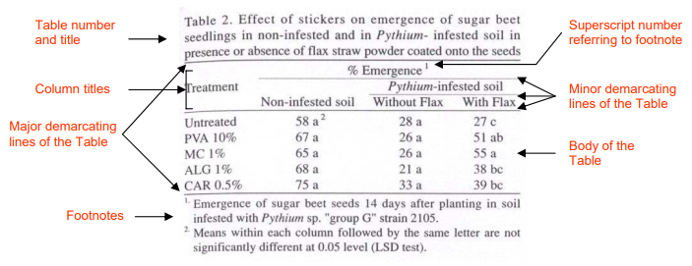

Anatomy of Figures

Figures are usually presented with a figure number only without any title. Graphs must have properly labeled axes: the axes’ titles must be descriptive of the data presented and include the units used. Use the space of the Figure properly; adjust the scale so you don’t have empty spaces. When drawing a Figure, indicate both the individual points (mean ± SE) and the best fit curve if the data are presented as a graph.

Each Figure must have a legend; however, the legend is NOT written below the figure when writing the lab report. The legends of all the figures are typically written on a separate page called “Figures Legend” page. The legend should start with the figure number followed by a short description explaining the data presented in the Figure. Like foot notes, legends must explain what the data are, how the data were collected, the sample size, how statistical analysis was performed and must also define the symbols and/or acronyms presented. Do not restate the axis labels (e.g., Absorbance versus concentration). For example:

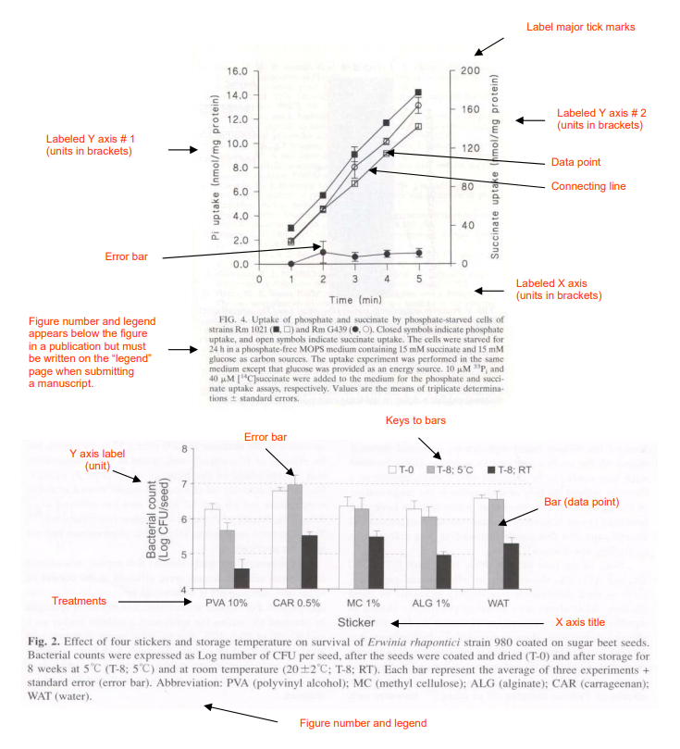
Other tips for writing a Results section
- Introduce the results that you are going to describe. For example, start by indicating which enzyme activity was measured, for which substance are you measuring the absorption, etc. Do not start your sentence by “Table 1 shows ..”.
- Figures can be abbreviated to Fig. in the written section of the Results. Table is always written in full.
- Do not try to explain sources of errors in the result section.
- Do not explain how or how often you performed your measurements or for how long. This should be in the M&M section.
- Do not present the same data in both a Table and a Figure. Choose the format that more clearly displays your results.

VI- Discussion

In the discussion section, review the most important results you obtained and provide an interpretation of what the results may indicate by comparing and contrasting your data with data published by other researchers. A discussion section where data are discussed without any comparison with data found in the scientific literature is not a discussion section!

The discussion section should be organized in paragraphs without subtitles. Each paragraph should start with the description of one important set of results followed by the interpretation of your results by comparing them with results previously published.

Remember that the main focus of the discussion is to compare and contrast the data you obtained with data published by other researchers.
  - If you obtain data similar to data that have been published, this provides additional evidence that these data are reproducible, that similar reactions occur in different organisms for example. This can be indicated by a sentence like:
    - Adams et al. (1988) also showed that ….
    - This result was also described by Koni and Smith (2007).
  - If the data obtained are different from data previously published, discuss the difference(s) between the data (the published article may have used another strain of bacteria, use a different incubation time, etc.) to try to explain why you obtained different results.
  - When referring to the work of others, do not paraphrase what the authors wrote in their article (this is plagiarism! Check the Web site below for more information about plagiarism), instead write it in your own words and make sure you reference the work properly.

- Explain how your data improve the general knowledge/understanding of the topic.

The discussion section should end with a brief concluding paragraph that includes a statement or comment on the most important findings of the experiment and provides an answer to the problem presented in the introduction. You can also suggest future work or new avenues that need to be addressed. The following are examples on how the paragraph can begin:

“We have shown…”
“This study demonstrates…”
“In conclusion…”
“Our data are consistent with…”

To cite the reference in the discussion section, simply report the last name of author followed by the date of publication (John, 2003). If there are two authors, report the name of the two authors followed by the date of publication (Smith and Kenedy, 1999). If there are more than two authors, report the name of the first author followed by “et al.” and the date of publication (Conaly et al., 2004).

Other tips for writing a Discussion section:
- Ensure all literature cited in the discussion are properly referenced in the reference section.
- Discussion section is not a Materials and Methods section: Do not describe how the experiment was performed in your discussion section (unless you are comparing your techniques with previously published techniques).
- Discussion section is not a Results section: Do not describe the results obtained in your tables. Instead, present one significant result or a set of significant results and explain what the result may suggest in light of what others have found. If there are discrepancies with what has been published, give suggestions for these discrepancies. Then present the next significant result and repeat the above exercise. Discuss the results in the same order they are presented in the Results section.
- Introduce what you are going to discuss. Do not write “In experiment 4.2……”. Instead, briefly explain what experiment 4.2 is about.
- Do not use sentences like: “It is a given…”; “it is obvious”; “I think that this happened because…”. Also write using the impersonal tone.
- Do not write statements such as “This conclusion supports the hypothesis.”; “My hypothesis was proven to be true.”; “The results agree with the predictions.” (Which results? Which prediction?). Instead, you should write something like:

“Our data confirm the assumption that salinity impairs germination by preventing imbibition.” Or “These results were also described in John et al. (2002)”.

VII- Reference/Literature cited

The reference section comprises the full citation of all peered-reviewed articles and books that are cited in the text of the manuscript (mainly in the Introduction and Discussion sections). Do not include other reading you may have done on the subject (e.g., internet sites, textbooks). All references listed in the References section must be cited in the body of the text.

The requirements for this section can vary from one journal to the next. Use the format below for your manuscript and lab report. The full citation of the journal articles must have the following format:

List all author names and initials, the year of publication, the article title, the journal’s name, the journal’s volume and page numbers of the article.

Organize the references in alphabetical order of the first author’s last name. If referencing papers from the same first author, organize the references in chronological order. Finally, if the same authors have published two articles in the same year, distinguish the two articles by placing “a” and “b” beside the date.

Acceptable references:
- Peer-reviewed journal articles
- Scientific book chapters (no textbooks)
- Proceedings from conferences

If you decide to abbreviate the name of the journal article;
- Make sure you use the correct abbreviation; check the following web site (https://woodward.library.ubc.ca/research-help/journal-abbreviations/)
- Abbreviate all the journal names or none of them (be consistent)

Examples

Peer-Reviewed Print Journals

Bowers, J. H., & Locke, J. C. (2000). Effect of botanical extracts on the population density of Fusarium oxysporum in soil and control of Fusarium wilt in the greenhouse. Plant Disease, 84(3), 300-305.

Chakraborty, U., & Chakraborty, B. N. (1989a). Role of rhizobitoxine in protecting soybean roots from Macrophomina phaseolina infection. Canadian Journal of Microbiology, 30(3), 285–289.

Chakraborty, U., and Chakraborty, B. N. (1989b). Interaction of Rhizobium leguminosarum and Fusarium solani f. sp. pisi on pea-affecting disease development and phytoalexin production. Canadian Journal of Botany, 67(6), 1698–1701.

Ellis, R. J., Timms‐Wilson, T. M., Beringer, J. E., Rhodes, D., Renwick, A., Stevenson, L., & Bailey, M. J. (1999). Ecological basis for biocontrol of damping‐off disease by Pseudomonas fluorescens 54/96. Journal of Applied Microbiology, 87(3), 454–463.

Ellis, R. J., Timms‐Wilson, T. M., & Bailey, M. J. (2000). Identification of conserved traits in fluorescent pseudomonads with antifungal activity. Environmental Microbiology, 2(3), 274-284.

Kutcher, H.R., Lafond, G., Johnston, A.M., Miller, P.R., Gill, K.S., May, W.E., Hogg, T., Johnson, E., Biederbeck, V.O., and Nybo, B. 2002. (2002). Rhizobium inoculant and seed-applied fungicide effects on field pea production. Canadian journal of plant science, 82(4), 645-661.

Peer-Reviewed Online Journals: Use the same format as the print version but add the doi (digital object identifier). See below for example and web site:

Zhou, F. X., Merianos, H. J., Brunger, A. T., & Engelman, D. M. (2001). Polar residues drive association of polyleucine transmembrane helices. Proceedings of the National Academy of Sciences, 98(5), 2250-2255. https://doi.org/10.1073/pnas.041593698.

https://lib.nmu.edu/help/resource-guides/how-guide/apa-style-7th-edition

Book Chapter or Proceedings

Stapleton, J.J., DeVay, J.E., and Lear, B. (1991). Simulated and field effects of ammonia-based fertilizers and soil solarization on pathogen survival, soil fertility and crop growth. In DeVay, Stapleton, & Elmore (Eds.), Soil Solarization (pp. 331-342). CRC Press, Inc.

Miller, J.H. (1972). Experiments in molecular genetics. Cold Spring Harbor Laboratory.

Final Note

Please be advised that students are responsible for their own work. Students must ensure that their work abides by the university’s guidelines and policies regarding academic integrity and plagiarism, which are available through the university’s website.

Manuscript Check-List

Before handing in, check the following:

- Is your title short and descriptive; does it give the reader a clear idea of the content of the paper.
- Is there enough background in the introduction to establish the importance of and context for the question? This is fairly arbitrary. However, by the end of the introduction, is should be clear to the reader what will follow?
- Is your purpose or research question clearly stated?
- Are there transitions between all sections and paragraphs to create flow and unity?
- Does the order of paragraphs make sense? (e.g., maybe the transitions seem forced because they aren't in the right order). Do you simply need to rearrange paragraphs, generate more content, or delete irrelevant material?
- Remove anything that is not essential.
- Are your sources reliable, representative, and convincing? There should be a balance between your own insights and expert opinions.
- Is everything that should be referenced, referenced?
- Does the conclusion comment on the most important findings of the experiment and provide an answer to the problem presented in the introduction?

Order of the different sections of the manuscript

- Title page (no page number) with 5 key words
- Page number starts the page of the abstract
- Order of the sections
  - Abstract
  - Introduction
  - Materials and Methods
  - Results
  - Discussion
  - References
  - Legend Page (if figures are present)
  - Figures and Tables
- All text must be double spaced and font 12 (from abstract to legend page)

