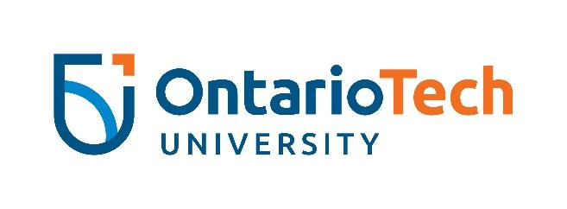

Digital Community Crew 2022-2023
Members of the Digital Community Crew are passionate about strengthening and fostering feelings of pride and community at the university. These students work as a team to plan campaigns, create content, and promote the Digital Community with the goal of enhancing feelings of belonging at the university.

This position is for students interested in using their creativity to create a welcoming and connected campus community, focusing on digital engagement.

TIME COMMITMENT:
This position runs from March 2022 to April 2023. During this time, the Digital Community Crew will
- Complete Personal Branding training (one and a half hours total, mandatory) by September 2022.
- Complete a virtual Content Creation training (less than one hour, mandatory) by September 2022.
- Complete a Campaign/Event Planning training by September 2022.
- Attend bi-weekly one-hour-long Digital Community Crew meetings to brainstorm and plan events and campaigns and curate content.
- Expect to spend up to 10 hours a month creating content, planning events, and promoting the Digital Community.
  - Two to three hours of meeting for event planning.
  - Up to four hours of event and/or campaign coordination.
  - One to three hours of content creation.

RESPONSIBILITIES:
- Work as a part of a team to plan digital campaigns and physical activations of those campaigns that are accessible and engaging, with the goal of giving students the opportunity to interact with students outside of the classroom and bridge the divide between online/offline interactions;
- Work independently and as a part of a team to curate content for the Digital Community in the form of (including but not limited to): blogs, quizzes, videos, music playlists;
- Collaborate with other university departments and student clubs to build community;
- Act as the representatives of the Digital Community, a space for students and their voices;
- Work closely with Digital Community Coordinator to develop promotions and campaigns for the Digital Community;
- Participate in program assessment, which may include feedback forms, evaluations and/or focus groups.

OUTCOMES:
- Build or strengthen your personal brand;
- Develop interpersonal and leadership skills;
- Gain tangible skills in project management, event organization and leading campaigns/initiatives;
- Learn and improve writing skills for blogging and social media using content creation goals outlined in training;

