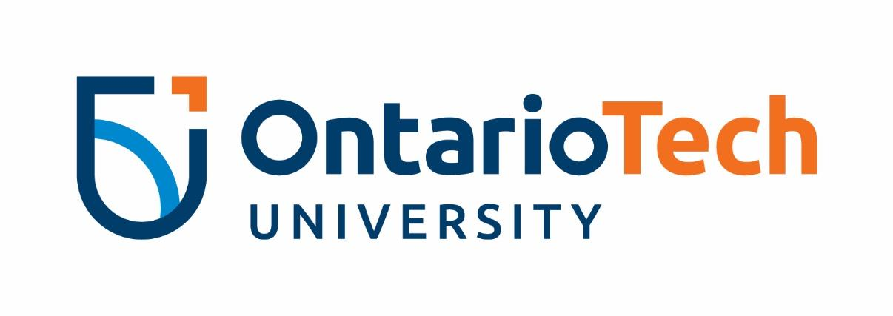
Equity Advocate
Equity Advocates are students interested in a broad range of human rights issues, including sexism, racism, ableism, transphobia, homophobia, sexual violence, and more. The Equity Advocates develop and deliver student-led initiatives to promote an equitable living, learning, and working environment for Ontario Tech students.

This position is for students interested in collaborative and community engaged learning to gain greater self-knowledge and leadership skills in the realm of equity.

TIME COMMITMENT:
This position runs from March 2022 to April 2023. During this time, Equity Advocates will:
- Complete required Ambassador Level 1 Training (8 hours total, mandatory)
- Attend the Equity Advocate Meet and Greet with the Equity and Inclusivity Advisor (1 hour)– March 2022
- Attend Equity Advocate training (6 hours total, mandatory) – May 2022
- Participate in a minimum of 3 Equity Advocate team meetings (1 hour each, mandatory) – June-August 2022;
- Participate in bi-weekly Equity Advocate team meetings to develop equity initiatives (1 hour each) – September 2022-April 2023.
- Attend Fall and Winter Reading Week Co-teaching Days (5 hours each session) - October 2022 and February 2023
- Expect to spend 3 hours per week outside of regular meetings for additional collaborative work, project work, and event planning and facilitation.

RESPONSIBILITIES:

- Work collaboratively on a team of Equity Advocates to develop and deliver programming and educational materials to support an equitable campus community;
- Work closely with the Senior Equity Advocates and Equity and Inclusivity Advisor for guidance on the development and delivery of equity initiatives;
- Collaborate with other university departments, groups, committees, and student clubs at Ontario Tech to address specific social justice and equity initiatives;
- Act as a role model of a balanced lifestyle, demonstrating respect for self, others, and for the community by ensuring activities and interactions with students are equitable and respectful;
- Promote equity and social change issues, events, content, and concepts through personal networks and seeking opportunities to collaborate with others;
- Participate in program assessment, which may include feedback forms, evaluations and/or focus groups.

DESIRED SKILLS AND EXPERIENCE:
- Interest in a broad range of human rights and equity issues, including sexism, racism, ableism, transphobia, homophobia, sexual violence, and more;
- Self-awareness and openness to critical self-reflection as a means to encourage personal development;
- Willingness to speak with unfamiliar groups of students, staff, and faculty on matters related to equity;
- Ability to listen respectfully to different perspectives while remaining non-judgmental;
- Handles confidential and sensitive issues with tact, discretion, and empathy;
- Effective project management skills with strong attention to detail while working within a team of other student leaders;
- Understanding of anti-oppressive practices and intersectional approaches to equity work;
- Passion to generate positive social change.

Please note: You must complete Level One of the Ambassador Program to be an Equity Advocate.
If you have not yet completed Level One of the Ambassador Program, you will have the opportunity to complete it at the Ambassador Day to be scheduled for Spring 2021. Please proceed with applying for the Equity Advocate position and be prepared to attend the Ambassador Day in Spring 2022.
Your offer will be conditional until completion of Level One.

