Job aid: Creating TA/RA Contracts

When creating a contract, here are two important points to remember:

- What pool status does this person belong to? Do you know the definitions of each of the pool status’s? Refer to the Collective Agreement on the Ontario Tech website, Article 12:

https://shared.ontariotechu.ca/shared/department/hr/Working-at-UOIT/teaching-assistant-research-assistant-and-invigilator-ca.pdf

- Are you using the correct position number that coincides with that person’s pool status?

For example: position number 5TN939 – “N” represents non-student, ensure this classification is in the appropriate pool as per the Collective Agreement definition.

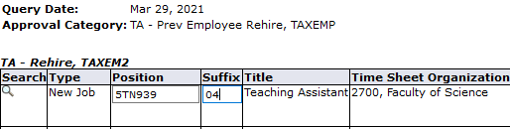

Refer to the listing of position numbers for your faculty here.

