**Virtual Team Building Activities**

**March 2020**

Team building brings people together by encouraging collaboration and teamwork. These types of activities help people see each other in a different light and allow them to connect with each other. Team building assists to foster genuine connections, deeper discussions, and improved productivity.

While in-person activities might always be preferred, video conferencing is a very effective means of communication.

Some team building activities are described below:

**Contents**

**Little Known Facts About Me** 2

**Video Roundtable** 2

**Two Pictures** 3

**Virtual Tour** 4

**Deserted Island** 4

**Picture Sharing** 4

**Scavenger Hunt** 4

**Can You Hear Me Now?** 5

**Exciting Sponge** 5

**Never Have I Ever: Rated E Edition** 5

**Online Team Building Bingo** 6

**Icebreaker Questions for Virtual Team Building** 7

**Exciting Sponge** 7

**Never Have I Ever: Rated E Edition** 7

# **Little Known Facts About Me**

– a game where each member guesses published weird and wonderful facts about their teammates

The objective of this game is to connect with your team members on a personal level.

Most virtual teams don’t have the opportunity to speak with each other often so this activity helps team members learn about each other.

**Here’s how it works:**

Ask each team member to send 3 facts about themselves (not related to their current work and preferably not known to anyone on the team) to the facilitator.

The facilitator enters those facts in a spreadsheet in random order. The spreadsheet will look similar to this sample with 3 team members:

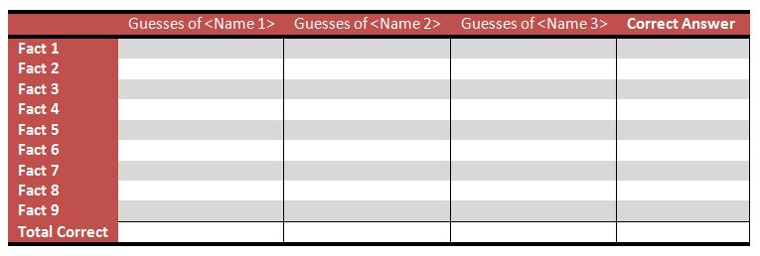

The facilitator starts by reading the first Fact. Team members guess who they think that fact belongs to by speaking up in turn. The facilitator types those guesses into the spreadsheet while sharing it on a screen virtually (Google Meets). When everyone has made a guess, the facilitator moves to the next fact. When all of the facts have been discussed the correct answers are revealed.

To reveal the correct answers, you might:

* Ask “who is this one?”
* Suddenly reveal a hidden answer column and then talk about each fact
* Review where the majority thought the fact fit and then ask the person to self-identify

# **Video Roundtable**

The goal of the meeting is to have everyone join a video conference and get an update from all the team members about what’s going well and what’s not. This is **not** a detailed status update to discuss issues or risks (which should have their own separate meeting), but rather general feedback about how things are going with the team.

The standing update questions are:

1. What’s one thing that’s been going great lately?
2. What’s one thing that can be improved upon?
3. What’s one thing that’s been going on with you personally?

A sample response could be:

1. *“We’re doing great with the latest requirements document – we finished it ahead of schedule and the customer is happy. Big shout-out to Mike for helping us last week and walking through it in detail with our lead engineer.”*
2. *“One thing we could do better is be a bit more responsive in email. I realize we’re all very busy, but we had to wait 48 hours for a response from the Ops team, and this is going to affect us negatively in the long run.”*
3. *“A personal update is that I’m opening the pool early this year. It’ll get us all outside into the sun. We’re all super-excited about it, and Charlie, my youngest, is looking forward to swimming with the blow-up dolphins.”*

The idea is to avoid “presenting” anything. The focus should be on the person talking because it’s a Video Roundtable, and team members are free to ask or comment on any of the responses so that it feels like an open forum.

An optional idea is to ask everyone on video to bring along their favorite beverage – coffee, tea or soda – to the meeting so that it feels like a virtual coffee break.

# **Two Pictures**

– an activity where everyone shares 2 pictures about anything unrelated to work, and spends 5 minutes talking to the team about them

**Here’s how the activity works:**

Ask everyone to share two pictures that mean something to them and spend 5 minutes talking about those pictures. Other team members are encouraged to ask questions.

Think of this as the equivalent of sharing personal items that might otherwise be in your office space where colleagues would see them. Dedicate 30 minutes where all team members share those 2 pictures in turn and talk about them.

This is somewhat similar to the “Little Known Facts About Me” virtual team building activity but focuses on pictures instead of text.

Here are some ideas for pictures you can share:

* Family and pets
* Home office space
* Vacation
* Hobbies, crafts, or memorabilia
* Pictures of something interesting you found online (like a gadget you want to buy)
* Art
* Fun items from past events (concert t-shirts, high school trophies etc.)

# **Virtual Tour**

Each team member takes a short video of their space or presents their space during a virtual team call. This is better suited to small teams but a great way to get to know each team member more personally.

# **Deserted Island**

In this virtual team building game, team members are given the scenario that they are stranded on a deserted island with seven objects, but they can only choose three. Make these objects as obscure and strategic as possible so that participants are challenged to really think and plan.

Split the team into groups and allow them to collaborate on which items they want to choose. Once all collaborations are complete, get onto a team video chat and discuss the results.

Examples of items are a bag of fruit, vegetable seeds, a pocket knife, a 100 ft rope, a bed sheet, a bucket, 2 liters of kerosene, a lighter…

Activities like this naturally make team members see each other as teammates and can create pride, healthy competition, and excitement within the team.

This activity might demonstrate how working together can yield better results, and can help virtual workers learn how to collaborate in a virtual setting.

# **Picture Sharing**

Picture sharing bonds the team with little effort. It can facilitate laughter and surprising responses that will leave employees feeling happy and connected.

In picture sharing set aside designated time, perhaps at the beginning of each meeting, for a team member to share one personal photo that is unrelated to work. This photo can contain pets, hobbies, gadgets, family members, etc. Then have the team member explain the photo.

Allowing team members to share part of their personal lives makes teamwork more fun and can bring a new element of friendship to the workplace.

# **Scavenger Hunt**

Send each member of your team a list of items to find. Each task completion must be accompanied by a photo of the team member completing it. Have all teams submit their photos to the place on WISC. Optional: Team members can stay connected while on the hunt through instant messaging and speaking on apps like Google Meets and WhatsApp.

Tasks can include:

Attempting a yoga pose or a Tik Tok dance, taking a photo of your reflection in something other than a mirror or window, wearing a funny hat throughout each task, cleaning a sink, etc. You can create the scavenger hunt yourself, or you can use an app like [GooseChase](https://www.goosechase.com/).com to facilitate it.

# **Can You Hear Me Now?**

More than just a sound check, Can You Hear Me Now is one of the best online games for virtual teams. You play this game in a virtual meeting room, and nominate one person to be the **speaker** and the rest are **artists**. The speaker uses a random image generator you can find online to source a suitable image, and the goal is to describe that image in such a way that the artists can draw it successfully.

The one guideline that makes this task challenging is that the **speaker** must only discuss geometric shapes. For example, you could say “draw a large circle and then their equidistant triangles” but not “write the letter E.” Limit instructions to geometric shapes and positions. The **speaker** will need to exercise extremely accurate communication skills. The artists need to listen and interpret.

(example of images to describe - <https://www.pinterest.ca/pin/504755070709419194/> )

# **Exciting Sponge**

Each team member presents a random object or a picture of a random object and creates a story about it. Alternately, they default to describing a sponge.

The goal is to exaggerate the truth about what makes that object amazing. For example, if someone picked up an alarm clock, they could say “this is a relic from the past and someday Indian Jones 2.0, AI edition, will travel back in time and snatch it up for a museum collection.”

# **Never Have I Ever: Rated E Edition**

Many people play a version of Never Have I Ever is college, and it often depends into NSFW topics. Instead, play the online team building version of this game with a “Rated E for Everyone” version. As the event organizer, you can write all the topics in advance or have team members submit topics that you filter for the group.

Never Have I Ever is typically a knock-out game, which means you start with five fingers up and lose a point for each of the topics that you have in fact done. For example, if the prompt was “never have I ever eaten sushi”, then everyone that has eaten sushi would put a finger down. The game works because it is fun and interesting to see who is an exception to each topic.

# **Online Team Building Bingo**

Online Team Building Bingo is a fun game you can play to engage remote workers. You start with a bingo board that has a number of action items or accomplishments on it. For example, when you hear someone say “sorry, I was on mute!” you can mark that spot off on your board, and similar for “wearing pajama bottoms to a video meeting.”

Bingo is a classic game that most people are familiar with, and the version for remote teams is a quick, easy and free way to get started with virtual team building.

Here is a bingo card you can use for your first game:

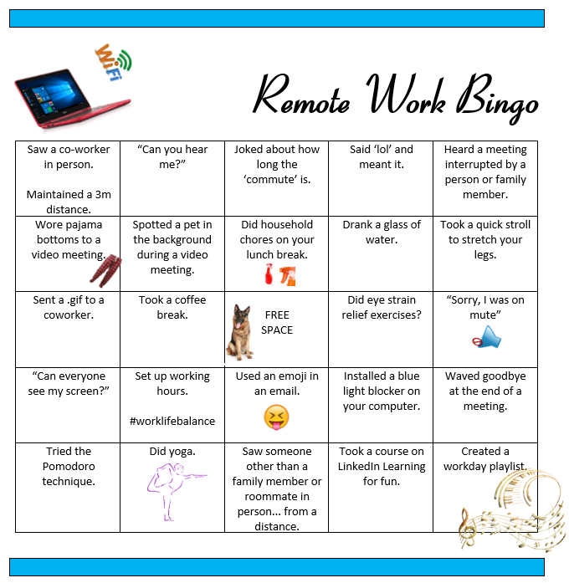

# **Icebreaker Questions for Virtual Team Building**

Icebreaker questions are simple prompts that allow you to get to know your peers better. For example, you can start a remote meeting by having each attendee share their name, role and what they like to eat for breakfast or any three items of your choice.

**A few tips and ideas for great icebreakers**:

* Unless you know each other extremely well, **start with easy questions**. Some of your team member will be nervous to share, and so you can start with simple questions like “dream vacation” or “cats vs dogs?”
* Before any person shares the answer to your icebreaker prompt, **announce who the next few people to share will be.** This process helps create order and is especially important for online meetings where you don’t have as many visual cues.
* **Go first.** As the meeting organizer or leader, you can ask the question and then be the first to share as an example to others. By starting, you give your team members a little longer to think about answers, and also model what a great answer can be.
* **Keep it short.** We recommend no more than 30 seconds per person.

Icebreaker Questions: [Click HERE](https://museumhack.com/list-icebreakers-questions/#bestquestions)

# **Exciting Sponge**

Exciting sponge is a quick and easy storytelling game that use can you for remote team building. To play on virtual team calls, each team member grabs a random object in arm’s length and creates a story about it, or can default to describing a generic sponge. The goal is to exaggerate the truth about what makes that object amazing. For example, if someone picked up an alarm clock, they could say “this is a relic from the past and someday Indian Jones 2.0, AI edition, will travel back in time and snatch it up for a museum collection.” Exciting Sponge is to remote team building activities as regular sponges are to washing the dishes; not necessarily essential, but pretty darn useful.

# **Never Have I Ever: Rated E Edition**

Many people play a version of Never Have I Ever is college, and it often depends into NSFW topics. Instead, play the online team building version of this game with a “Rated E for Everyone” version. As the event organizer, you can write all the topics in advance or have team members submit topics that you filter for the group.

Never Have I Ever is typically a knock-out game, which means you start with five fingers up and lose a point for each of the topics that you have in fact done. For example, if the prompt was “never have I ever eaten sushi”, then everyone that has eaten sushi would put a finger down. The game works because it is fun and interesting to see who is an exception to each topic.

<https://www.thecouchmanager.com/3-fun-and-easy-virtual-team-building-activities/>

<https://biz30.timedoctor.com/virtual-team-building/>

<https://museumhack.com/virtual-team-building-for-remote-teams/>