My HR Connection Performance Training Guide
Manager –Annual Performance and Development Conversation

Revision History

Version | Date | Description
1.0 | Dec 17, 2018 | Initial Draft
1.1 | February 8,2019 | Updates
1.2 | March 25, 2019 | Logo and rebranding
1.3 | March 9, 2021 | Updated to reflect changes to the 2020-2021 performance cycle

Revision History 2
1. Introduction 4
1.1. Objectives 4
- Annual Performance and Development Conversation Process 4
- Steps for completing the Annual Performance in My HR Connection 5

Introduction

Objectives
Upon completion of this manual, you will be able to:
- Understand the process for Step 3: Performance and Development Conversation from the role of a Manager.
- Successfully complete the required tasks of the Manager in My HR Connection.

Annual Performance and Development Conversation Process

Manager
Schedules meeting
Employee
Updates Status and Completes Self- ASsessment
Managers
Reviews and Rates
Manager and
Employee have Conversation
Manager
Sends Comments and Rating
Employee
Reviews and Signs Off
Figure 1: Annual Performance and Development Conversation Business Process

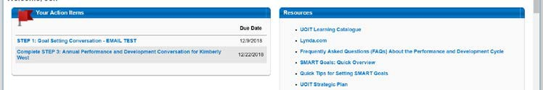

Steps for completing the Annual Performance in My HR Connection

 | Action | Steps to Execute
1 | You will receive an email notification to complete the Annual Performance and Development Conversation for your employee(s) | Receive Email in Outlook
2 | Log in to My HR Connection and select the related task for your Employee.
3 | Read the Overview of the task.  Scroll down and click Get Started to launch the task.

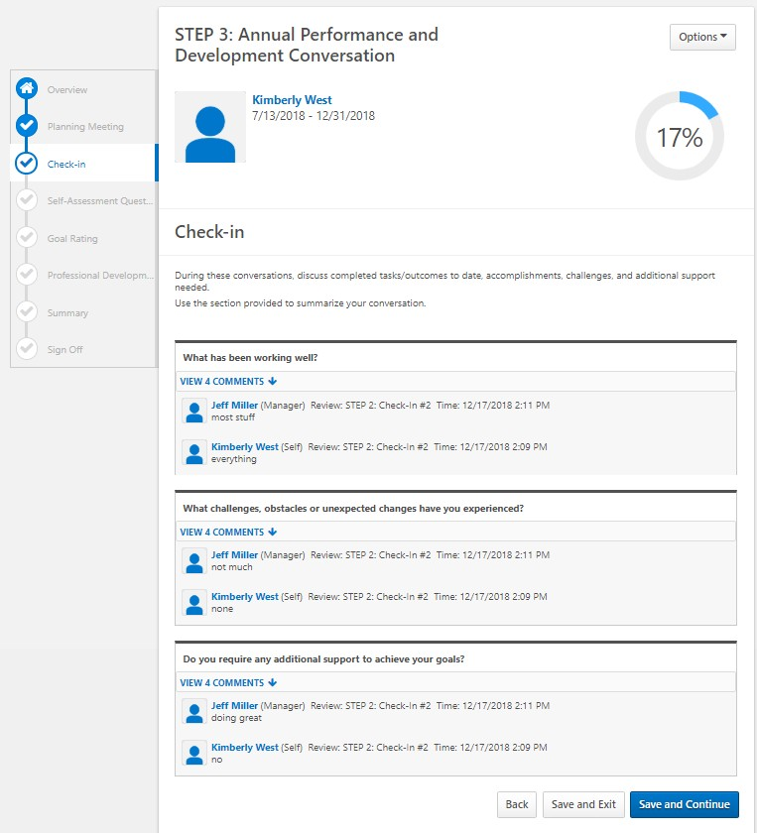
Act | ion Steps to Execute
9 Review the Mid- Cycle Check-in Conversations you have completed during the cycle with your employee.

Click Save and Continue.

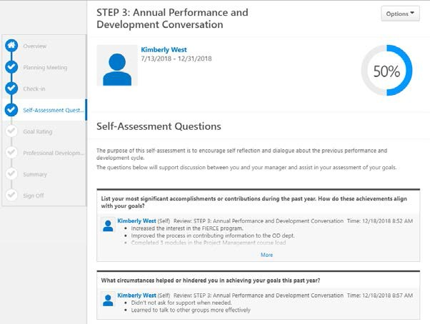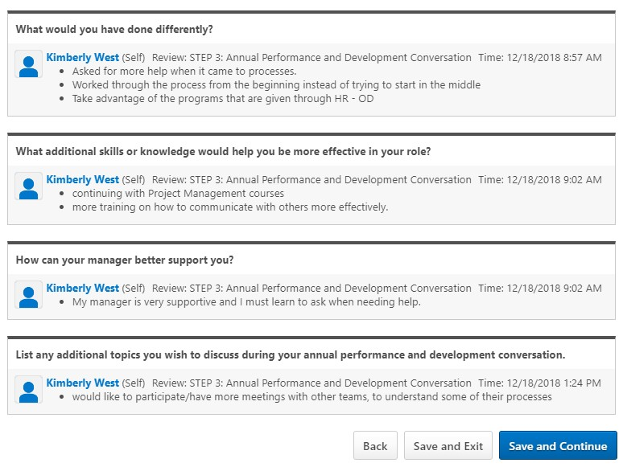
10
Action Steps to Execute
Review the Self- Assessment questions completed by the employee to help inform your overall assessment.
Click Save and
Continue.

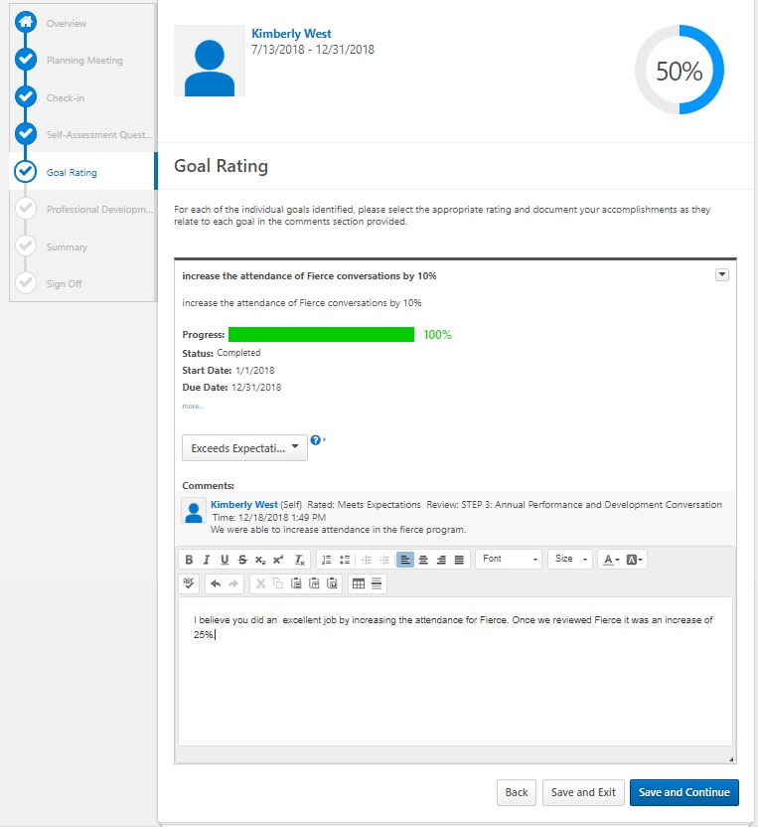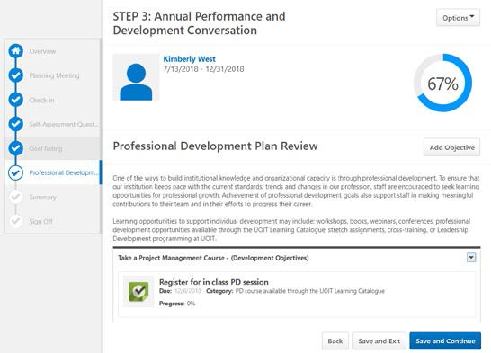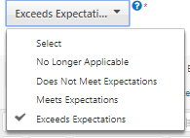
11
Action Steps to Execute
Review the self- assessment by the Employee and their comments.

For each goal and with each goal being equally weighted, select the rating against the goal.

Your rating is a final decision.

Provide comments to support your rationale.
12
Click Save and
Continue.
Review the status of the employee’s Professional Development Plan.
Click Save and
Continue.

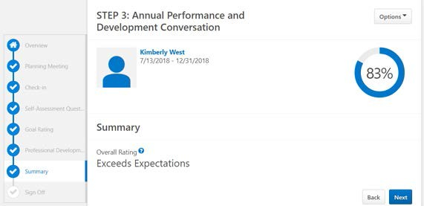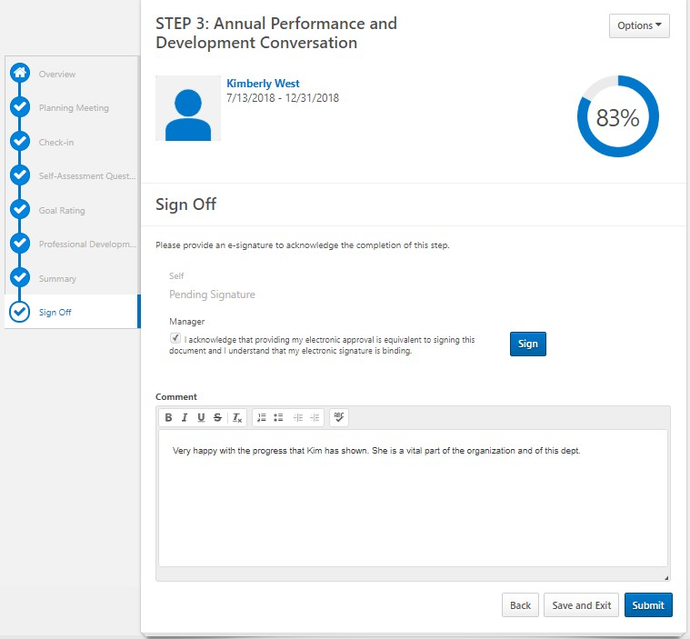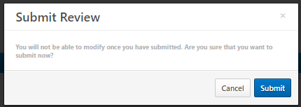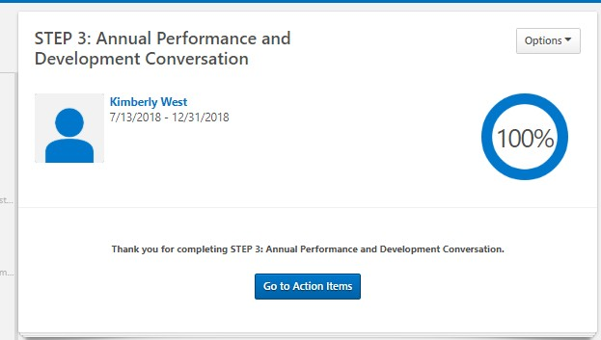
Action Steps to Execute
  - In this section, you will see your overall rating for this Employee.

Click Back to adjust your ratings
or
Click Next.
  - Enter final summary comments.

Click the check box to sign off on the Performance Development Conversation and complete Step 3 for this Employee.

After checking the sign off box, click Submit.
  - Click Submit again to confirm

Select Go to Action Items to complete tasks for other Employees
Or
Log out.

