My HR Connection Performance Training Guide
Individual Contributor –Annual Performance and Development
Conversation

Revision History
Version | Date | Description
1.0 | Dec 17, 2018 | Initial Draft
1.1 | February 8, 2019
1.2 | March 25, 2019 | Update logo and branding
1.3 | March 9, 2021 | Updated to reflect changes to the 2020-2021 performance cycle

- Introduction 4
1.1 Objectives 4
- Annual Performance and Development Conversation Process 4
- Completing the Annual Performance and Development Conversation in My HR Connection 5

Introduction
  - Objectives
Upon completion of this manual, you will be able to:
    - Understand the Annual Performance and Development Conversation.
    - Successfully complete the required tasks in My HR Connection.

Annual Performance and Development Conversation Process

Manager
Schedules meeting
Employee
Updates Status and Completes Self- ASsessment
Managers
Reviews and Rates
Manager and
Employee have Conversation
Manager
Sends Comments and Rating
Employee
Reviews and Signs Off
Figure 1: Annual Performance and Development Conversation Process

Completing the review in My HR Connection

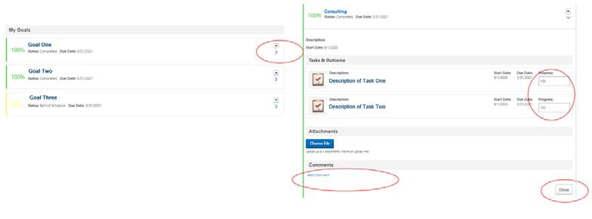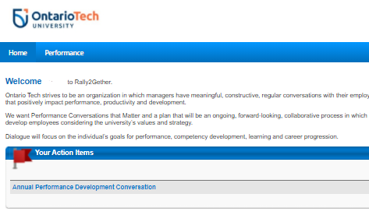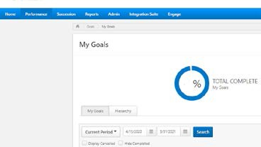
Action
1
You will receive an email to complete the Annual Performance and Development Conversation
2
To update your goals and goal status:

Hover over Performance and select Goals

Select the date range and click search
3
Expand each goal by clicking >

Adjust status/progress %

Enter comments Click Close
This updates your goals and goal status
Step to Execute
Receive Email in Outlook
4 Log In to My HR
Connection and click on the related task : Annual Performance and Development Conversation

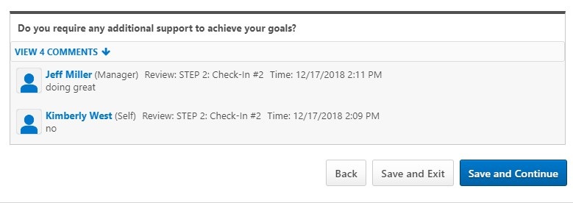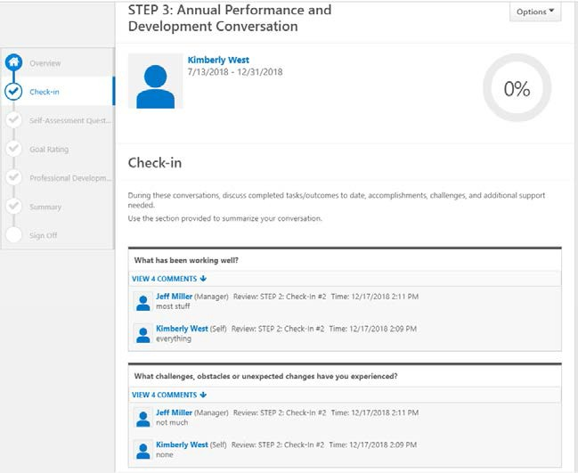
5
Action
Read the Overview
Step to Execute
Scroll down and click
Get Started to launch the Self-Assessment
6 Review the
comments from the Check-in. This page is view only.

Click Save and Continue

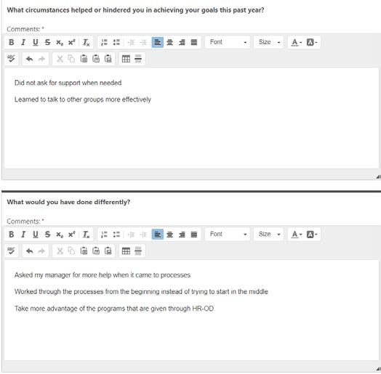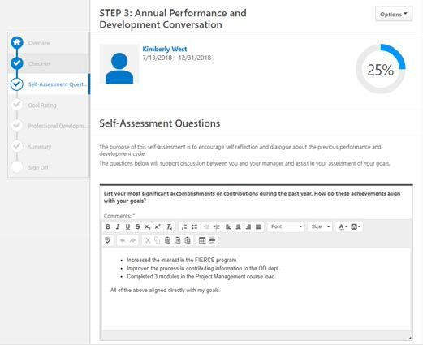
7 | Complete the Self- Assessment questions within the online platforms.

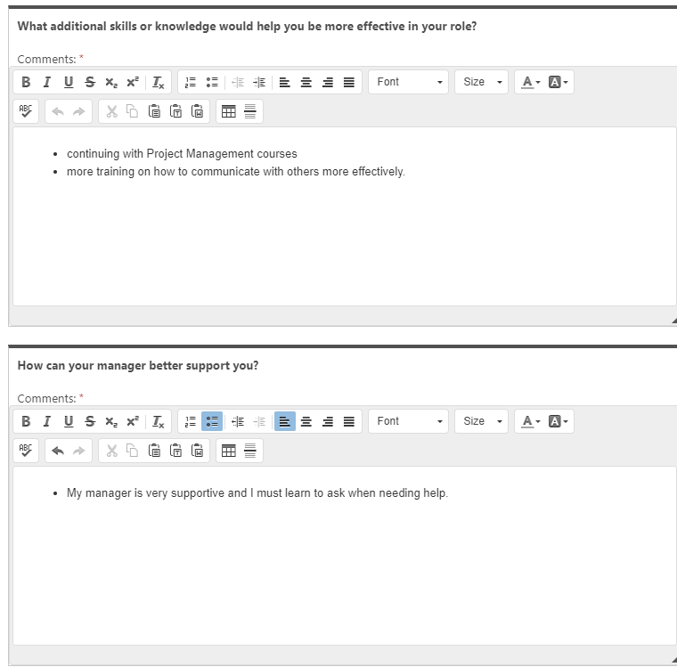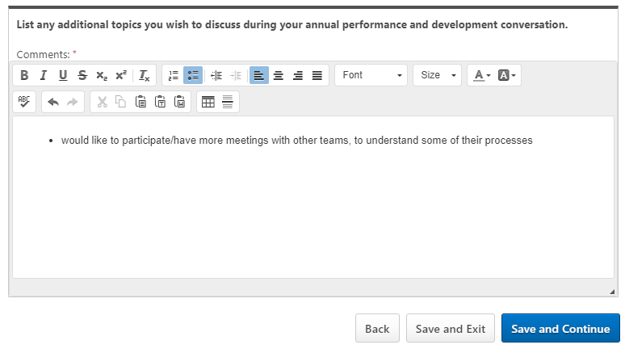
 | Action | Step to Execute
 | Click Save and Continue

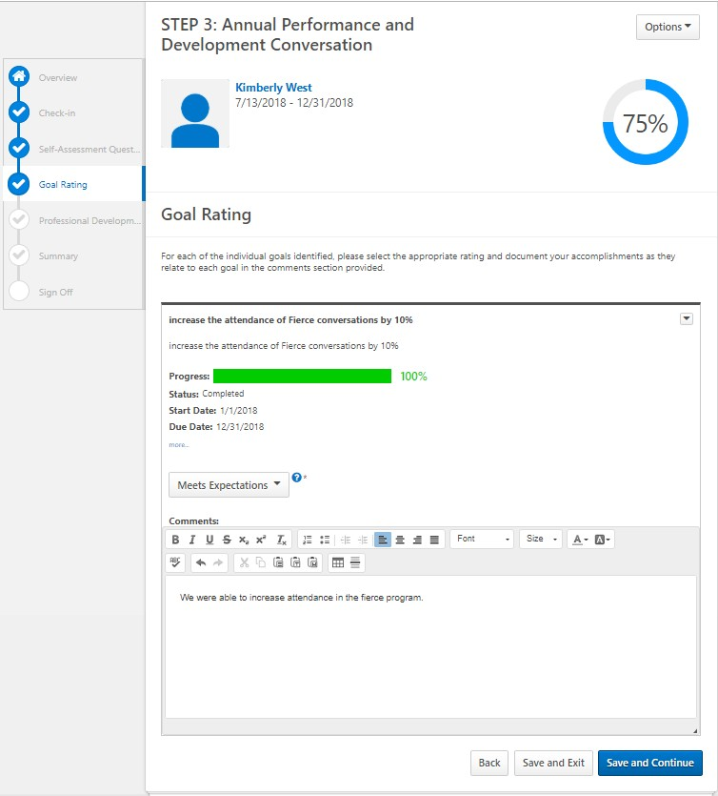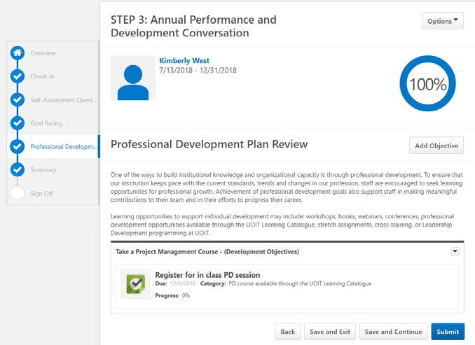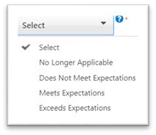

Action Step to Execute
- The Goal Rating section opens to review progress of your goals and you are able to comment on the status of each goal.

Click the dropdown arrow and select the option that best reflects your performance on this goal.

Click Save and Continue

- Once you have completed the Self- Assessment, you will be prompted to review your Professional Development Plan.

Click Submit when you have completed your review of this section.

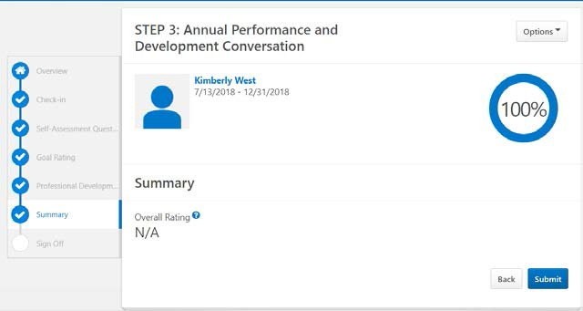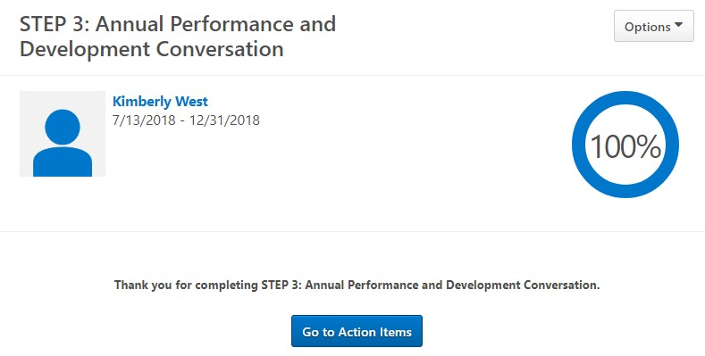

Action Step to Execute
- Once you click submit on the prior page, you will be prompted to submit again.

- Return to your Action Items or Log Out.

- You will receive an email to return to the online platform and review your manager’s comments and assessment after your manager has submitted their documentation.

This is likely to occur after your face to face performance conversation.

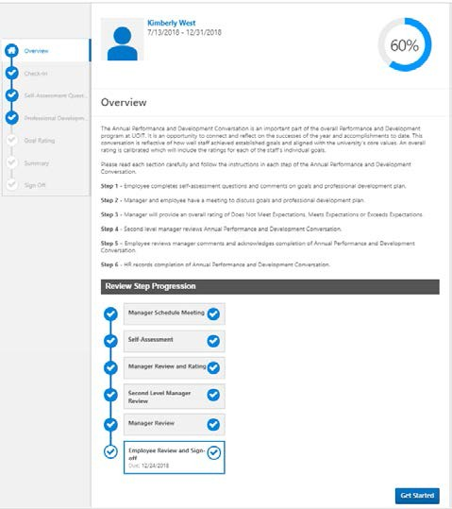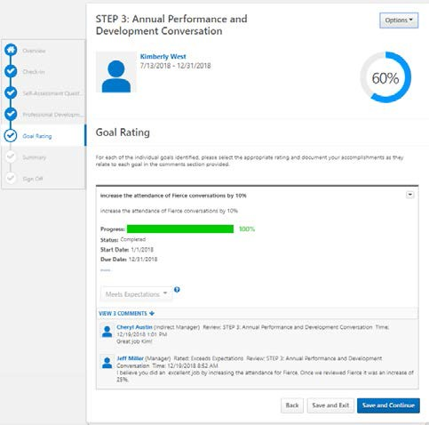Action Step to Execute
- Click Get Started

- Review your manager’s comments and rating.

Click Save and Continue.

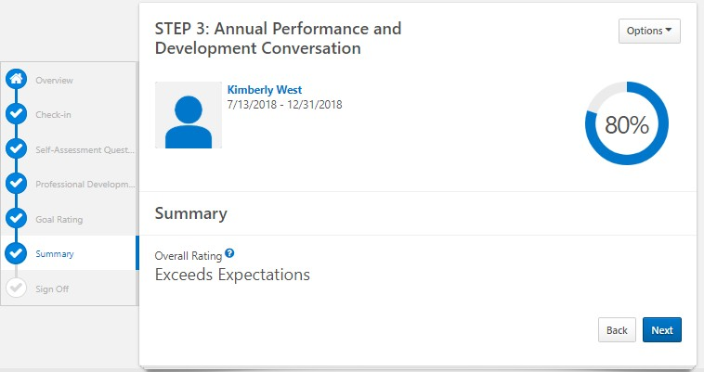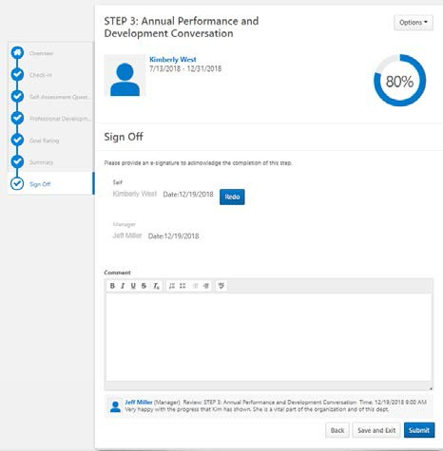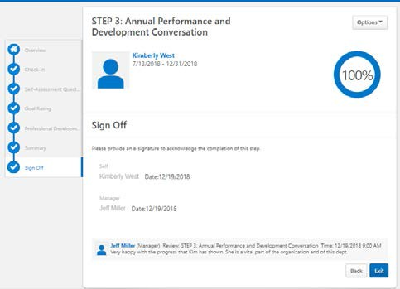Action Step to Execute
- View your Overall Rating.

Click Next.

- Select the Sign Off checkbox beside your name to acknowledge that you have reviewed the comments and rating for your Annual Performance
and Development Conversation.

Click Submit.

Click Submit again.

- You have completed your Annual Performance and Development Conversation.

Click Exit.

