This form is to be completed by the injured employee’s Supervisor.
To request support from Environmental Health and Safety please email healthandsafety@ontariotechu.ca.

1. Response Level
LEVEL 1: First aid only ☐  (Complete Sections 2-4) | LEVEL 2: Medical Aid / ☐  High potential near miss  (Complete Section 2-7) | LEVEL 3: Lost time injury☐  / Occupational illness  (Complete all sections) | LEVEL 4: Critical Injury / ☐Fatality  (Complete all sections)

2. Investigator Information
Investigator/Investigation Team/Job Titles:
Contact Email: |  | Contact Phone Number(s):
Date of Report: |  | Report Completed by:

3. Injured Person Information
Injured Person Name: |  | Position Type:  (e.g., employee, contractor, student)
Type of Employment:
Department: |  | Union / Contact:
Supervisor Name: |  | Supervisor Job Title:
Job at Time of Incident:
Length of Employment: |  | Time in Current Position:
Nature(s) of Injury: |  | Part(s) of Body Affected:

4. Accident/Injury Investigation
Date: |  | Time:
Location:
What was the work activity or task being performed at the time of accident/ injury?
What was the resulting outcome/consequences?
What object or substance caused the injury or illness?
Suggested Immediate Corrective Actions taken:  List all other corrective actions: | (Example: First aid provided, area secured, equipment removed, hazard corrected)
Training verification:  Required? | Yes ☐ No ☐
If yes, then please list what was the required training and if completed?

5. Witness Information: No Witnesses ☐
Name: |  | Department:
Contact Information:
Statement:
Name: |  | Department:
Contact Information:
Statement:

6. Contributing Factors and Root Cause Analysis
Failure/Direct Cause:
(What caused the injury)
- Why?
- Why?
- Why?
- Why?
- Why?
Root Cause(s):
(What allowed the failure to occur? May be multiple)
Potential Contributing Factors:
(See Section 9)
Risk Assessment:  (Risk of recurrence if no action taken) | Potential Severity: |  | Potential Likelihood:
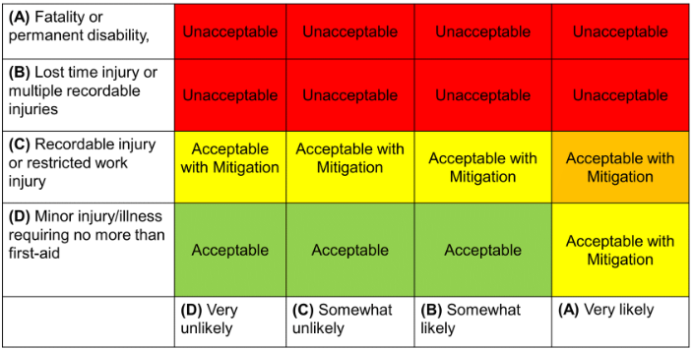
Overall Risk Rating:

7. Action Plan / Corrective and Preventative Actions (CAPA)
Item | Action | Responsible | Due Date | Date completed
1.
2.
3.
4.
5.

8. Department / Faculty / Leadership Review
Reviewer Name: |  | Job Title:
Date of Review: |  | Signature:

9. Environmental Health and Safety Review
Reviewer Name: |  | Job Title:
Date of Review: |  | Signature:

Please submit your completed form to Environmental Health and Safety at healthandsafety@ontariotechu.ca. Thank you.

9. Contributing Factors (check all that apply)

Human Factors  ☐Communication methods ineffective  ☐Directions not followed  ☐Fatigue  ☐Horseplay  ☐Indifferent, inattentive, complacent  ☐Operating without authorization  ☐Required training not completed  ☐Rushing to complete task  ☐Task not analyzed for hazards  ☐Unsafe action of another  ☐Other:  Nature of Task  ☐Communication difficult during task  ☐Complex task – many variables  ☐Failure to recognize task hazards  ☐Length of time to perform task  ☐Task changed after starting work  ☐Other:  Work Environment  ☐Congested/small working spaces  ☐Housekeeping conditions  ☐Lighting levels impacted visibility  ☐Noise levels impacted communication  ☐Required PPE inhibited movement  ☐Signs/labels missing/improperly located  ☐Weather conditions or temperature  ☐ Repetitive motion  ☐ Awkward posture  ☐ Forceful exertion  ☐ Manual material handling  ☐Other: | Process Controls – n/a  ☐Alarm messages/priorities unclear  ☐Arrangement of displays is confusing  ☐Controls operate opposite to normal  ☐Critical display information not obvious/visible  ☐Display labels unclear or ambiguous  ☐Repetitive alarms/messages  ☐Other:  Facilities / Equipment / Tools  ☐Access to equipment  ☐Equipment arrangement or placement  ☐Equipment guarding/protective controls  ☐Equipment labels unclear or missing  ☐Equipment LOTO (Lockout/Tagout)  ☐Equipment status unclear  ☐Facility design  ☐Facility/equipment change management  ☐Failure of facility equipment  ☐Preventive maintenance practices  ☐Procurement practices  ☐Proper tools unavailable or inadequate  ☐Other:  Management System  ☐ Policy/Procedure missing or inadequate  ☐ Change Management process absent  ☐ Incident trends not identified  ☐ Corrective action tracking ineffective  ☐ Resources limitation  ☐ Other. | Work Processes  ☐Communication between groups is inadequate  ☐Established procedure not used/followed  ☐Planning process inadequate  ☐Policies, administrative controls not followed  ☐Procedure not available or inadequate  ☐ Contractor activities not coordinated  ☐ Communication between groups inadequate  ☐Other:  Leadership & Supervision  ☐Communication methods are ineffective  ☐Expectations unclear/misunderstood  ☐Impact of concurrent activities not considered  ☐Inadequate participation in planning & preparation  ☐Inconsistent follow-through on expectations  ☐Lack of available resources  ☐Roles and responsibilities unclear  ☐Training inadequate  ☐Worker selection process inadequate  ☐ Corrective actions not implemented  ☐ Hazards/inspections not completed  ☐Other:

