Recipient App for iPhone
Installation and Registration/Guide

The following procedure walks a user through the installation and registration of their Alertus iPhone App.

Recipient APP for iPhone Installation and Registration/Guide
Before users can receive Alertus Mobile App Mobile Alerts the appropriate application must be downloaded, installed and configured on the user’s iPhone. Users must complete the following steps to download, install, and configure the Alertus Mobile App.

1. Download and install the Alertus Mobile Application from the App Store
2. Enter cirens in the Organization Code box, then click Next
3. Enter your email address in the Email box
4. Enter 226116 in the Pin box, then click Register
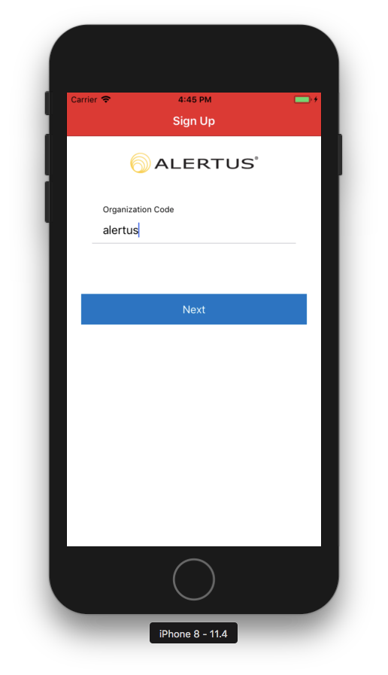 | 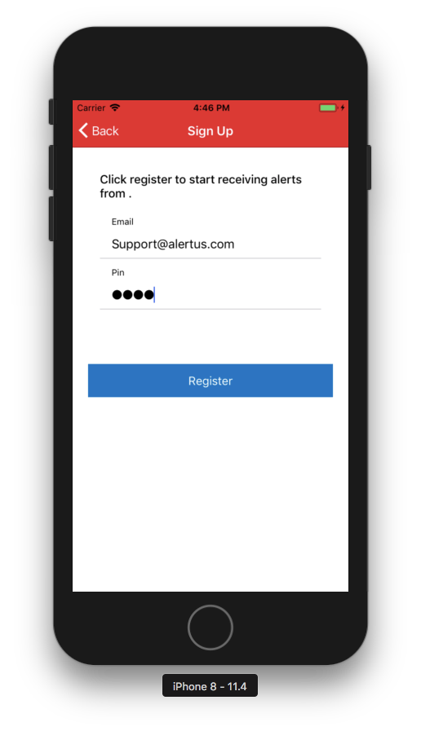
5. Select Allow when prompted “Alertus” Would Like To Send You Notifications

6. Go to Home Screen → Settings → Alertus → Notifications
7. Make sure Allow Notifications has a “Green Switch”
8. Change style from Temporary to Persistent. Now you should be able to receive messages!

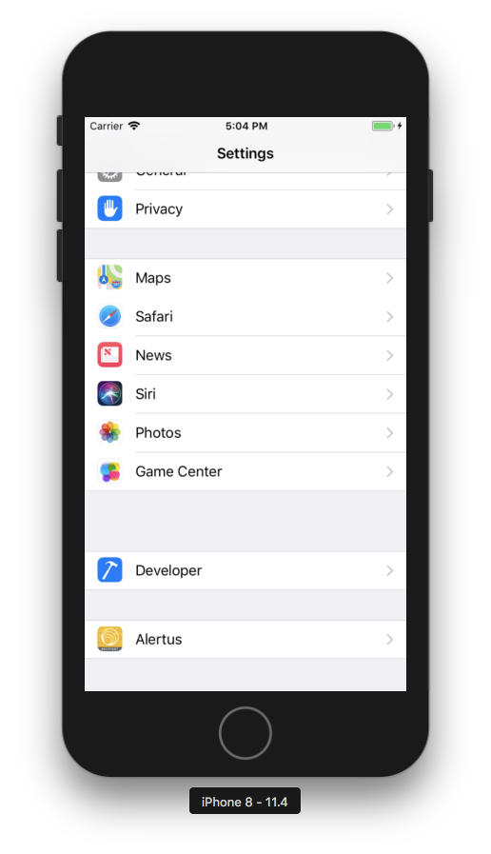 | 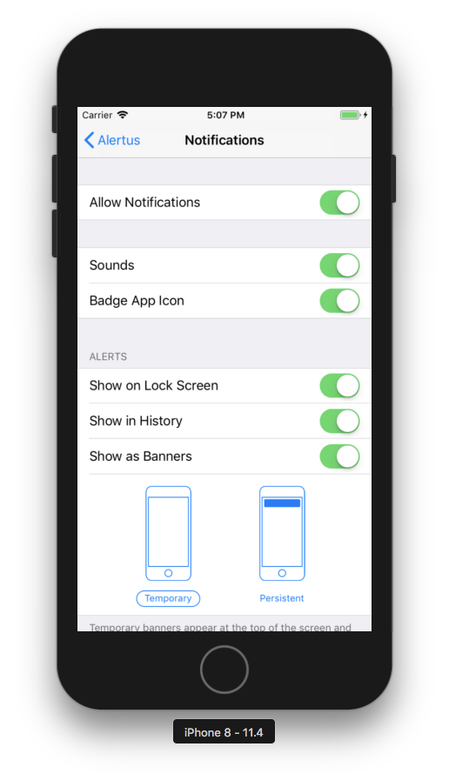 | 