Recipient App for Android
Installation and Registration/Guide

The following procedure walks a user through the installation and registration of their Alertus Android App.

Recipient App for Android Installation and Registration/Guide
Before users can receive Alertus Mobile App Mobile Alerts the appropriate application must be downloaded, installed and configured on the user’s Android Phone. Users must complete the following steps to download, install, and configure the Alertus Mobile App.

1. Download and install the Alertus Mobile Application from the Google Play Store
2. Enter cirens in the Organization Code box, then click Next
3. Enter your email address in the Email box
4. Enter 226116 in the Pin box, then click Register
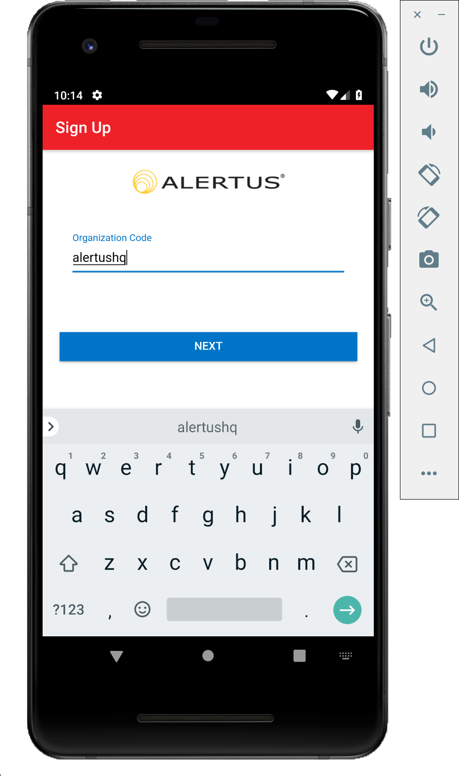 | 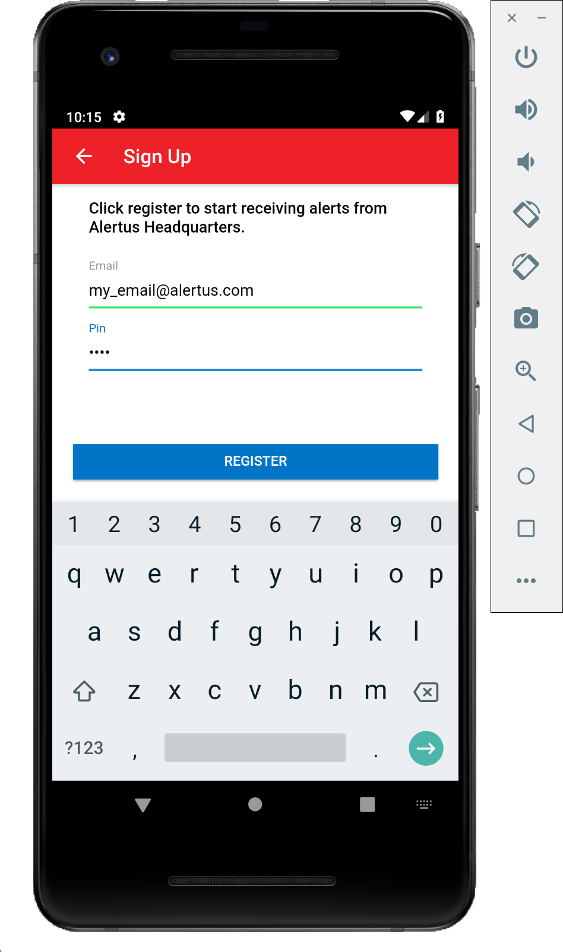

5. Go back to Home Screen
6. Go to Settings
7. Scroll down and select Apps
8.Scroll down and select the Alertus App
9. Select Notifications
10. Set the “Allow Notifications”, “Set as priority”, and “Preview in pop-ups” to “ON”. Depending on your Android Device, there may be variations in the Alertus App settings.

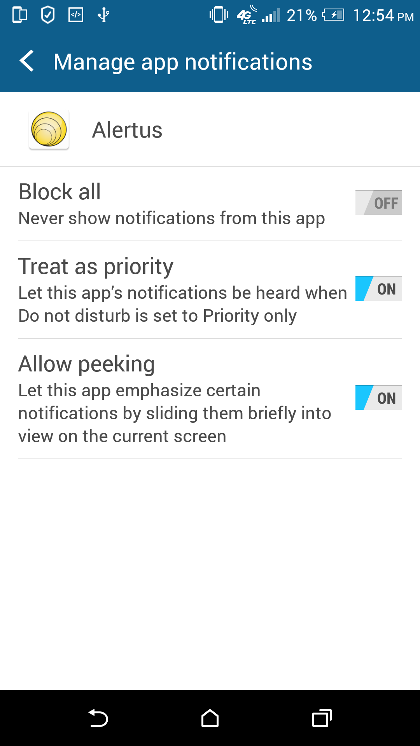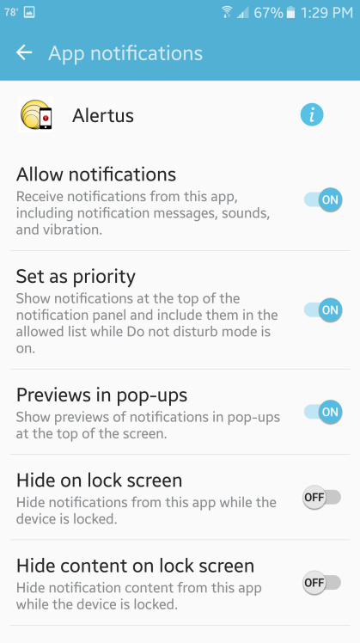

11. Go back to Settings by pressing the button twice
12. Scroll down and select Display. Depending on your Android Device, the LED settings are found under Sound & Notification
13. Scroll down and set “LED indicator” to “ON”

